SAMPLE SALE
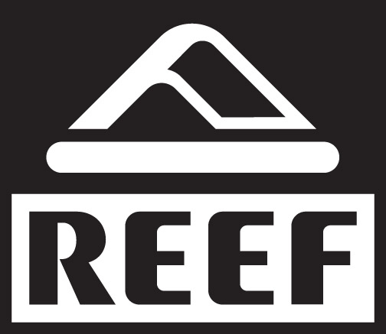
THIS SATURDAY, july 6TH
9AM to 2PM
1790 Hwy A1A Unit #103
Satellite Beach
(Across from Sun on the Beach Restaurant on A1A)
MENS-WOMENS-KIDS

-LOOK FOR THE TENTS-

!!ALL BELOW WHOLESALE- CASH ONLY!!

